nnnnnnnnnnnnnnnnnnn5
2022-23
Seasonal Report
Ambulance Patient Offload Time Special Seasonal Report

Week 47 (11/20/22 – 11/26/22)

Riverside County EMS System Status
Week 47 Summary
ALS Responses | ↓ | 4,768 9-1-1 responses in Riverside County — 1.4% DECREASE from previous week - Pg 2
Transports | ↑ | 3,378 transports in Riverside County — 2.6% INCREASE from previous week - Pg 2
Ambulance Patient Offload Delay (APOD) | ↑ | 989 APODs in Riverside County — 9.6% INCREASE from previous week - Pg 2
APOD Hours | ↑ | 677.0 hours — 29.3% INCREASE from previous week - Pg 3
APOD Compliance | ↓ | 70.7% APOD Compliance in Riverside County — 2.6% DECREASE from previous week - Pg 4
Emergency Treatment Services APOD | ↓ | 25 ETS APODs greater than 30 minutes — 28.6% DECREASE from the previous week - Pg 6
EMS influenza-like-illness (ILI) | ↑ | 219 ILI responses in Riverside County — 27.3% INCREASE from previous week – Page 8

This report and all published APOT reports can be found at:
http://www.rivcoems.org/Documents/Reports-Current

Prepared by Riverside County EMS Agency – November 28, 2022

special seasonal report

In an effort to monitor Ambulance Patient Offload Time (APOT) and influencing factors such as seasonal surge, Riverside County EMS Agency is publishing weekly reports. The following charts represent weekly aggregates of 9-1-1 Responses, Transports, and Ambulance Patient Offload Delays (APOD) for the past 16 weeks.
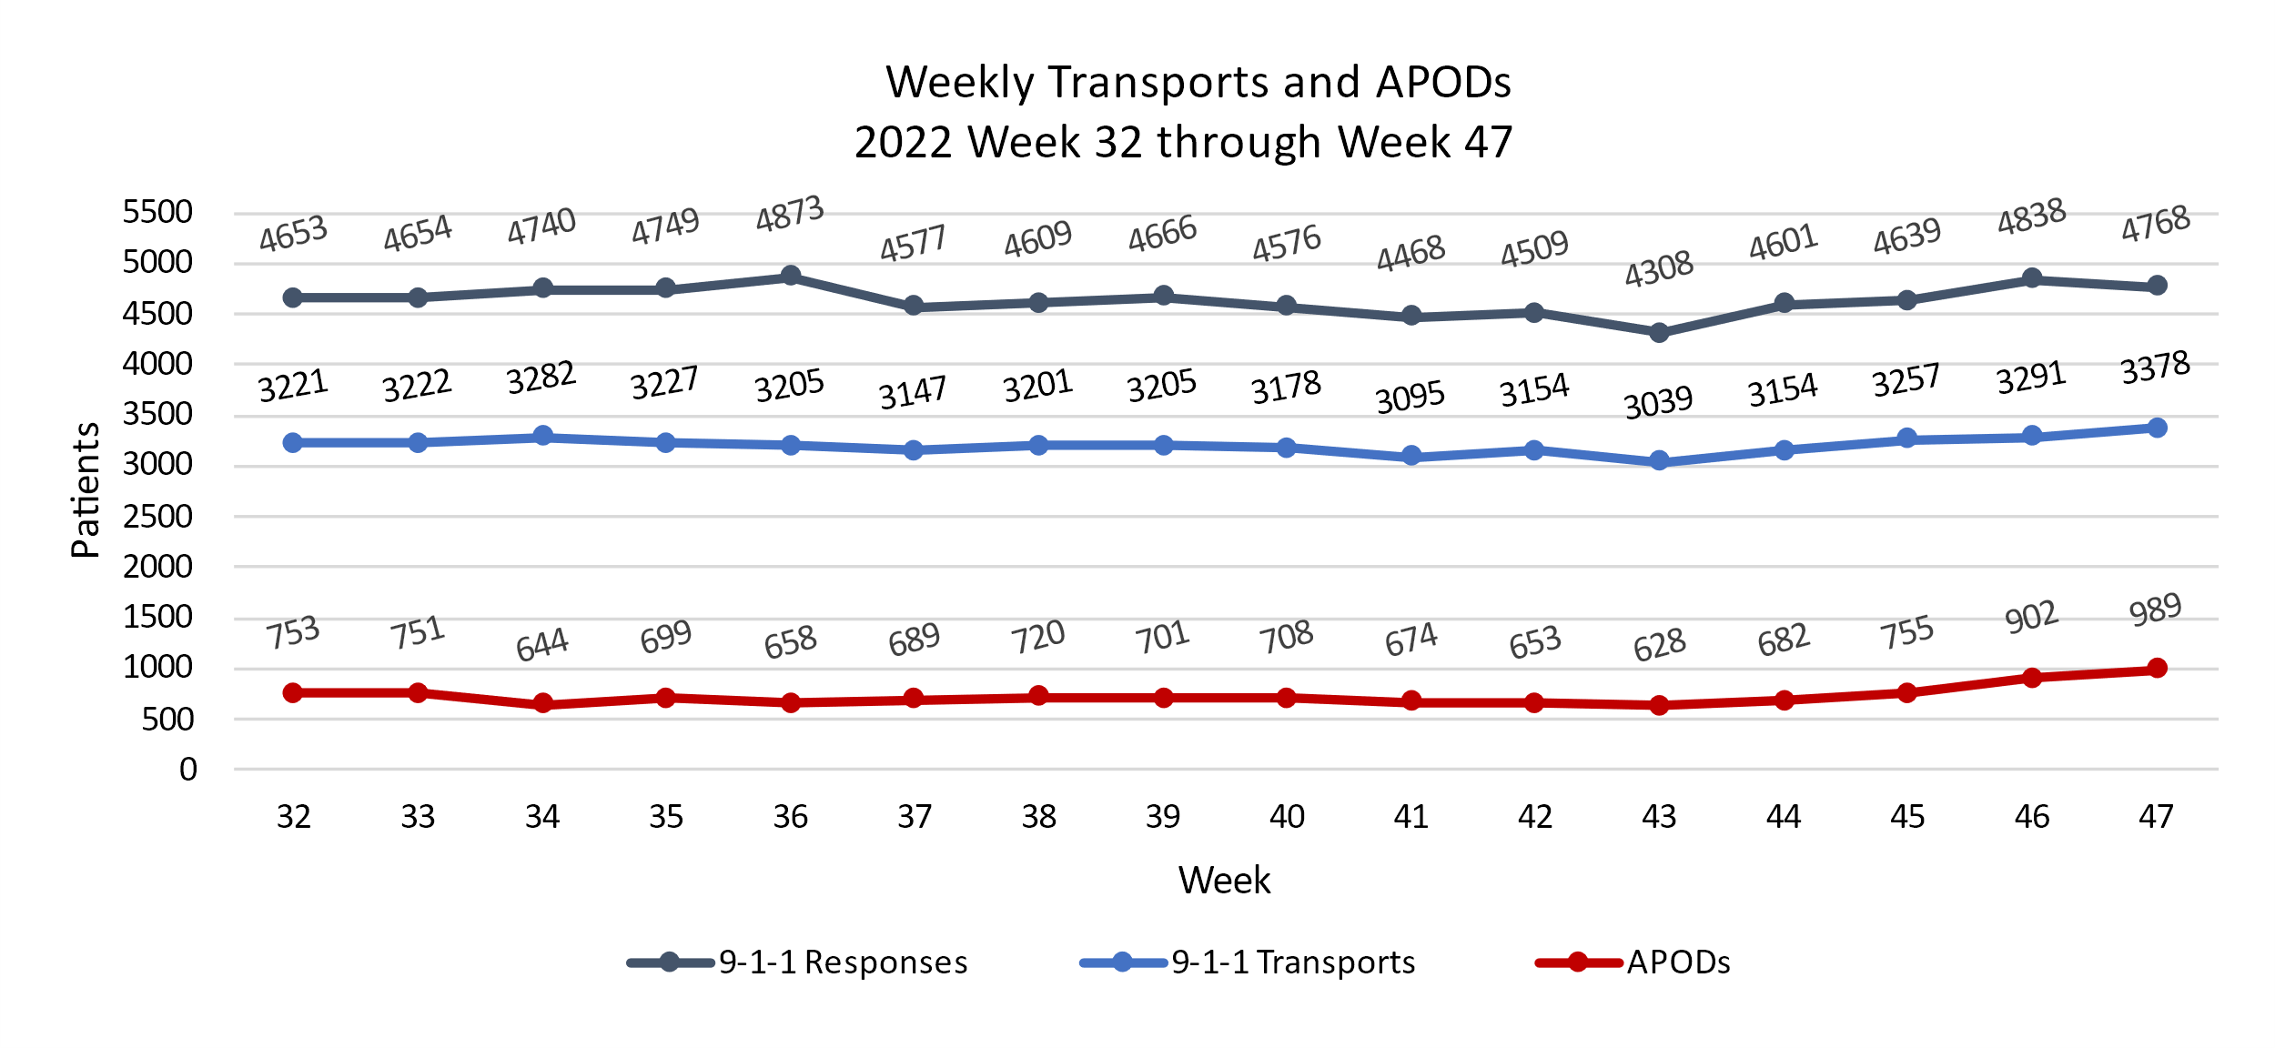

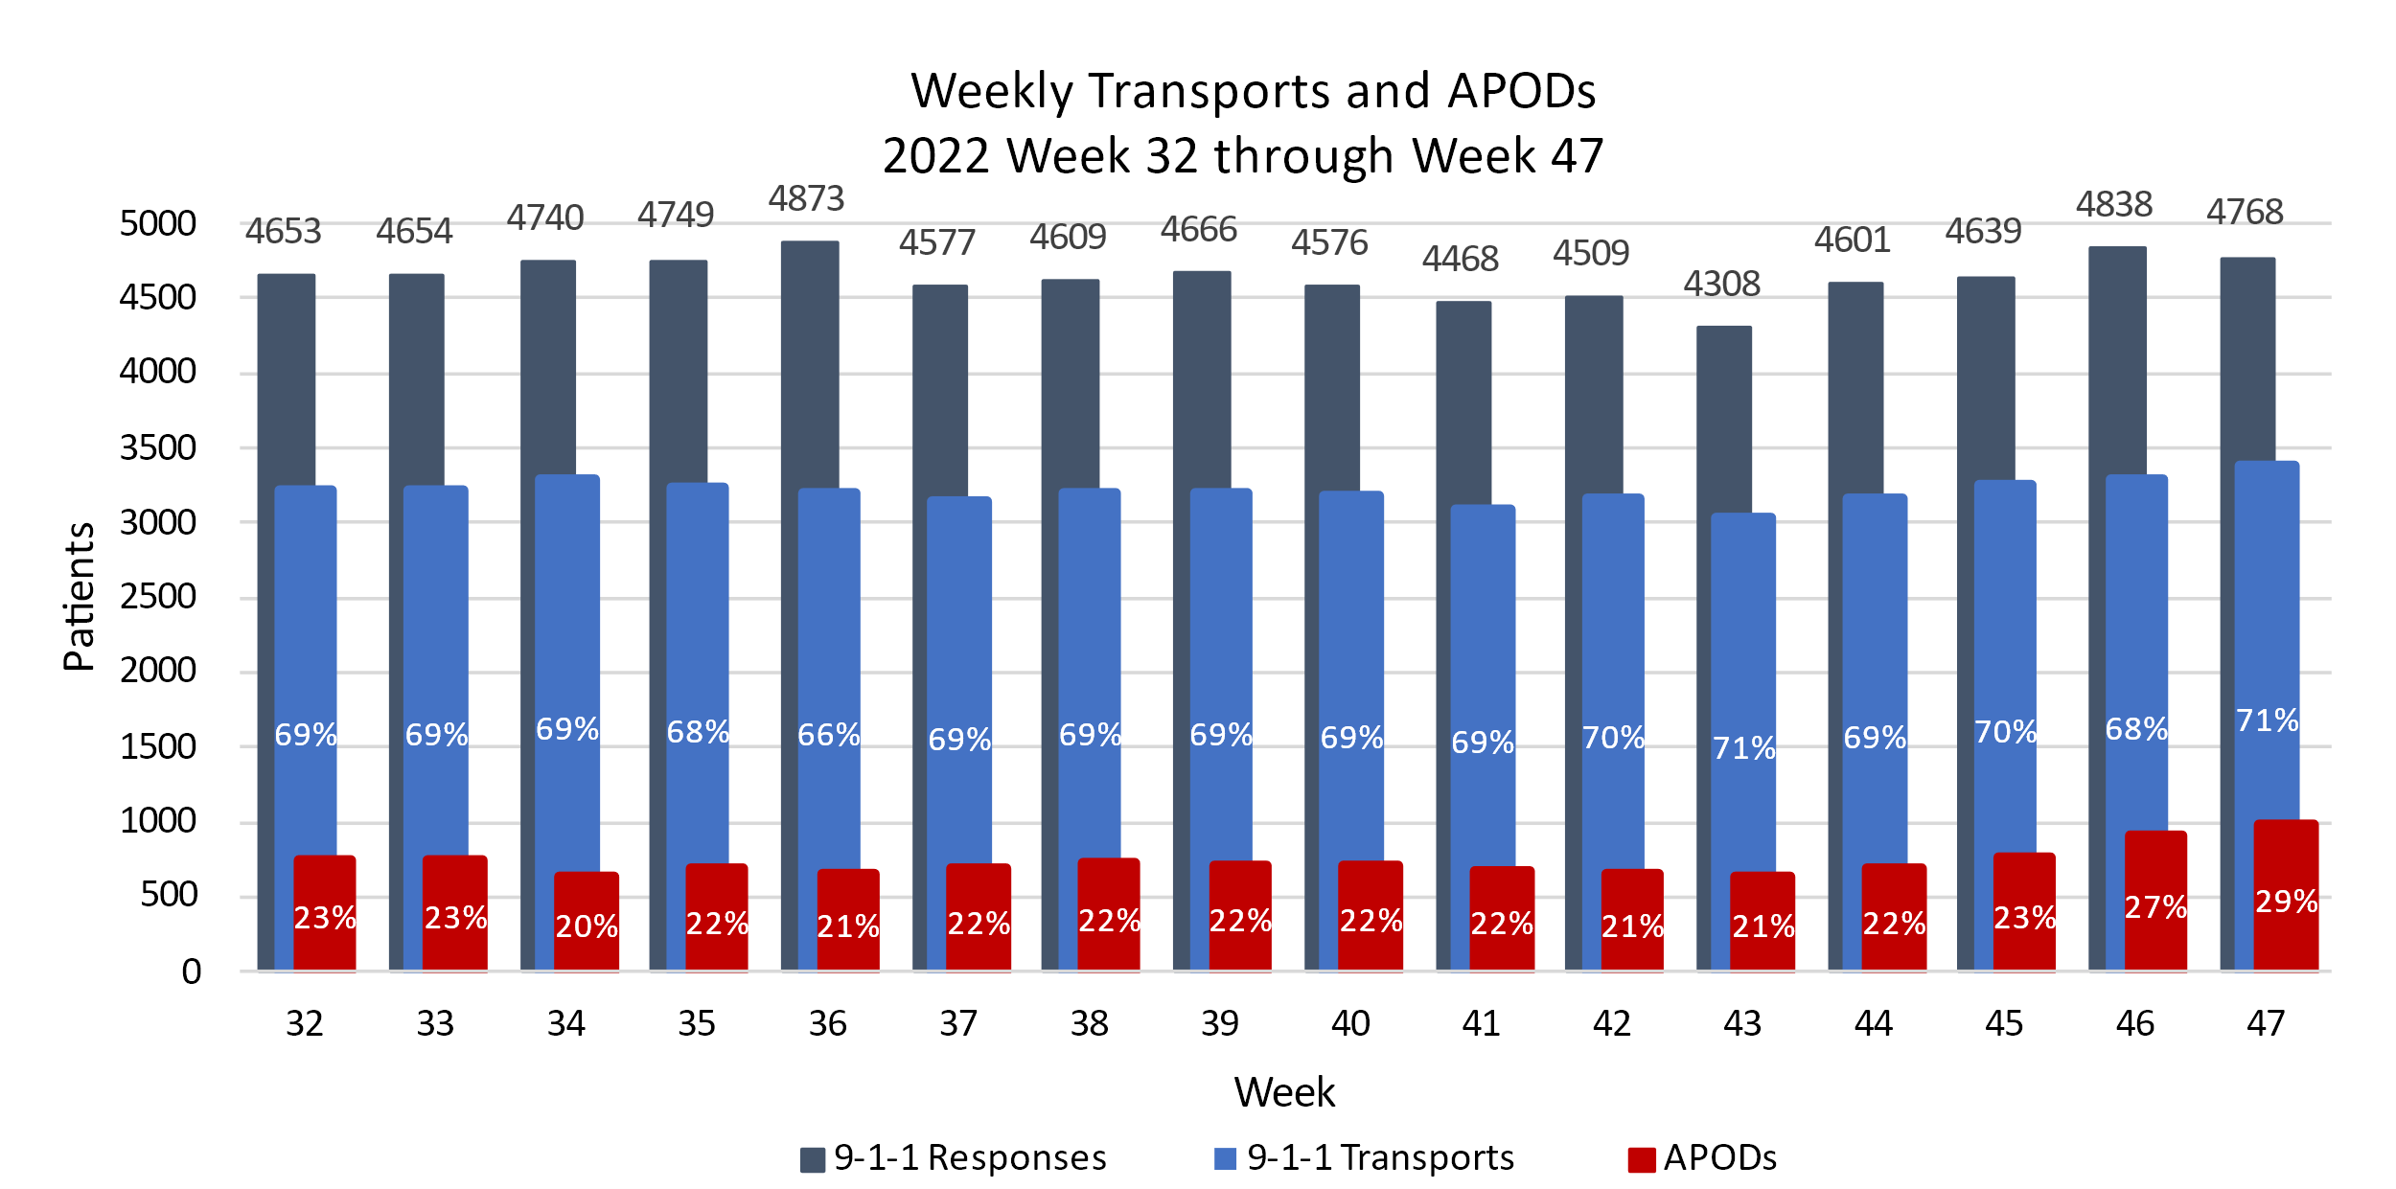
*Transports include only 9-1-1 transports to Riverside County hospitals

- During Week 47, there were a total of 4,768 ALS responses in Riverside County—1.4% DECREASE the previous week’s total of 4,838 responses.
- During Week 47, there were a total of 3,378 transports in Riverside County— 2.6% INCREASE the previous week’s 3,291 transports.
- During Week 47, there were a total of 989 APODs in Riverside County— 9.6% INCREASE from the previous week’s total of 902 APODs.

RIVERSIDE COUNTY AMBULANCE PATIENT OFFLOAD Time

The following chart represent weekly aggregate APOT and APOD hours (hh:mm:ss) for the past 16 weeks. APOT begins at patient arrival at hospital (eTimes.11) and ends when patient care is transferred to the hospital (eTimes.12). APOD calculation begins when APOT exceeds the 30-minute transfer of care standard defined in REMSA Policy 4109.
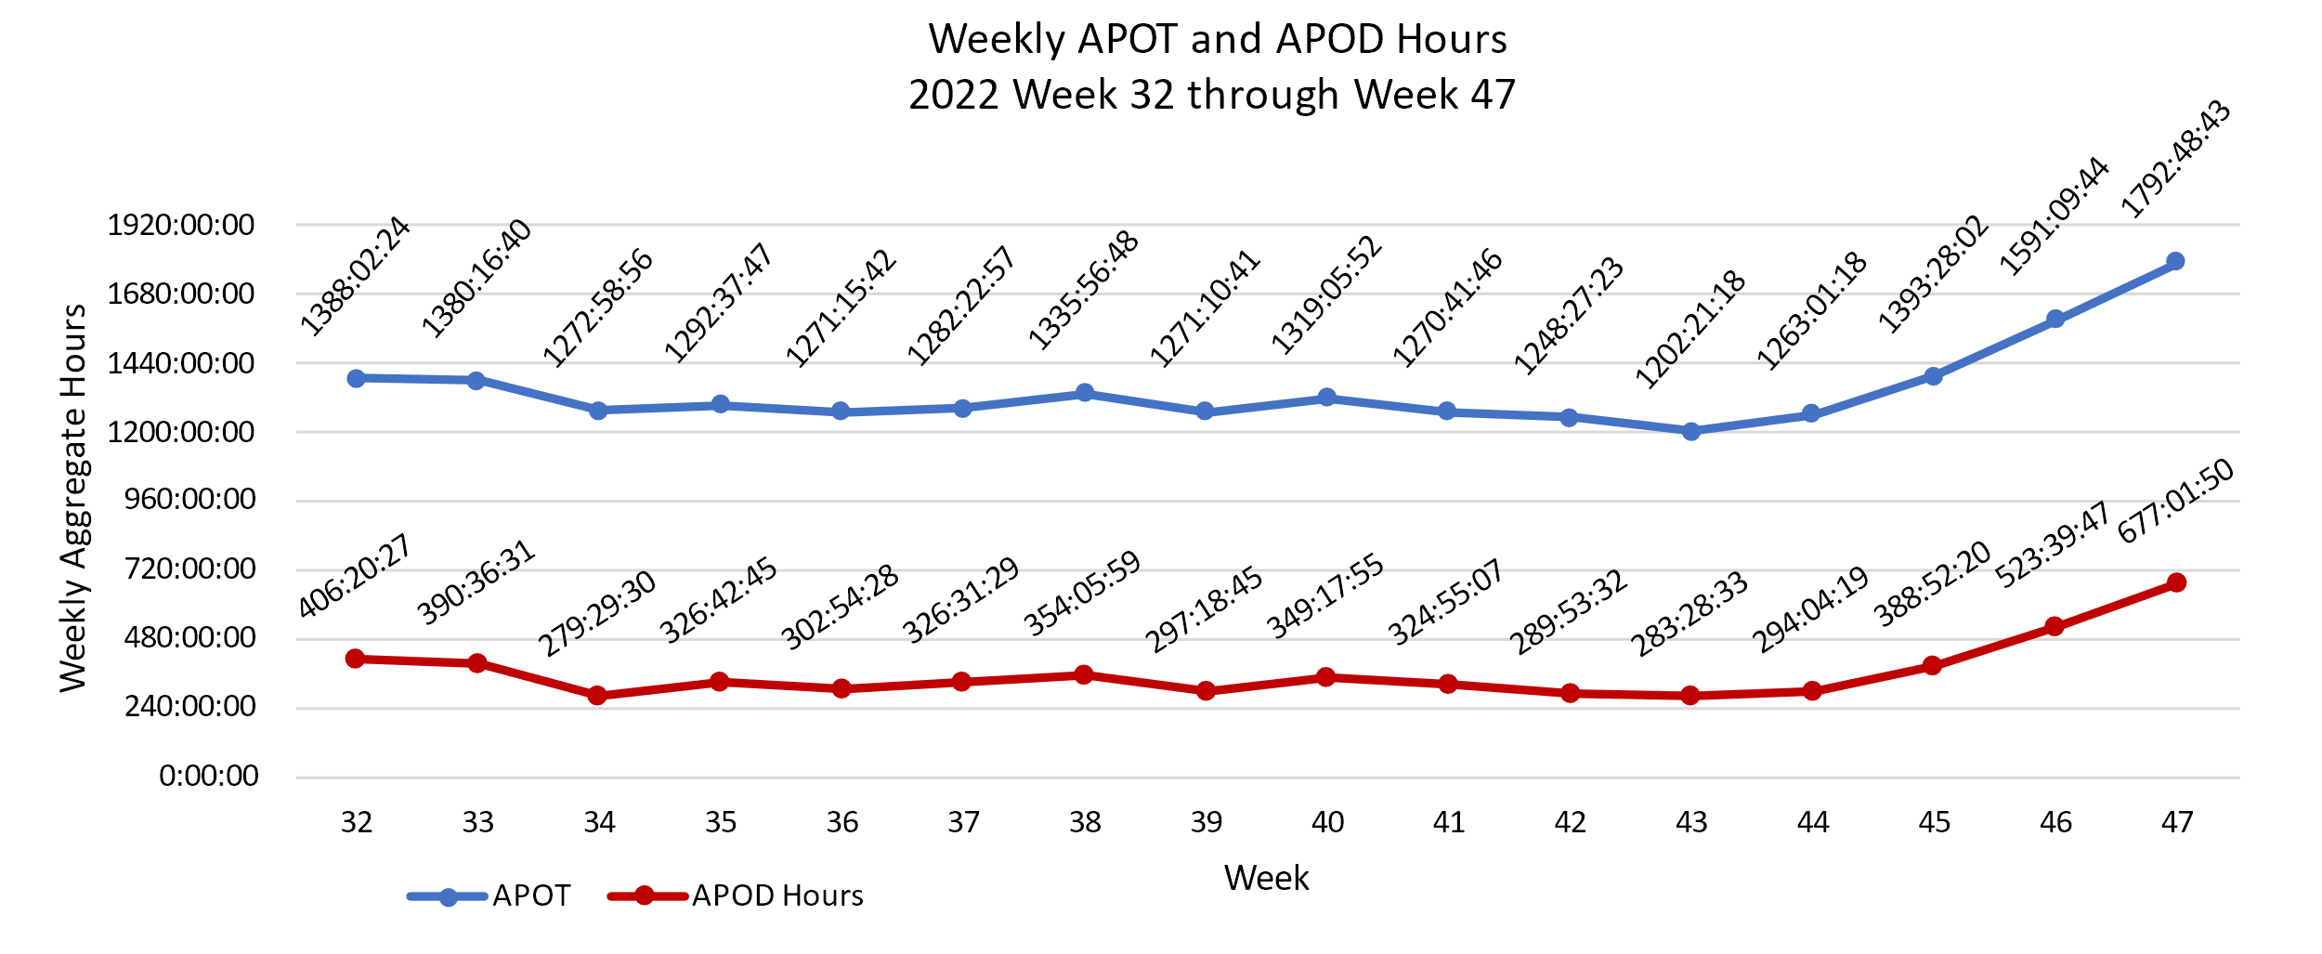

- During Week 47, APOT county-wide totaled 1792.8 hours — 12.7% INCREASE the previous week’s total of 1591.2 hours.
- County-wide APOD hours for Week 47 totaled 677.0 hours, a 29.3% INCREASE from the previous week’s total of 523.7 hours.
Data provided below illustrates total APOD time (hh:mm) by month over the last five years. This chart is a summation of offload time delays only and excludes the initial 30 minute period defined as the standard transfer of care time.
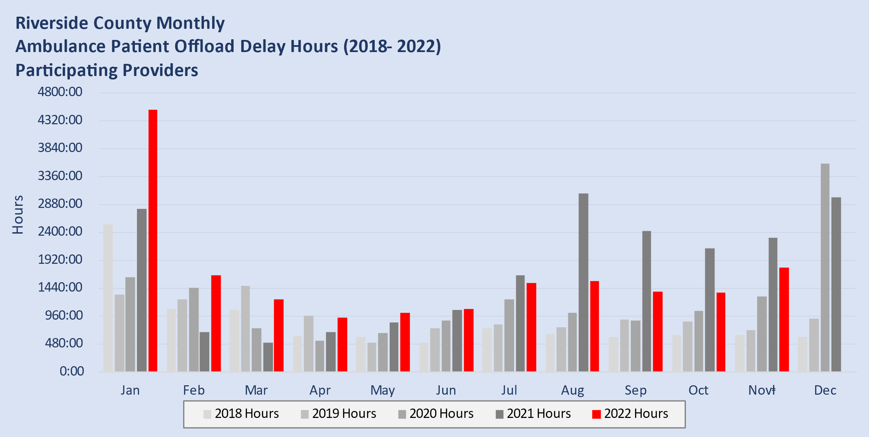
*Novⱡ is a partial month

Ambulance Patient Offload Time by Hospital

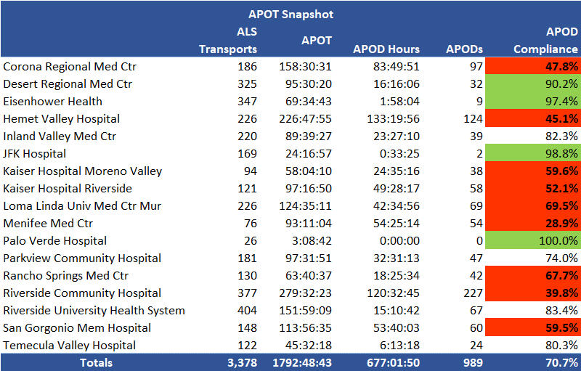

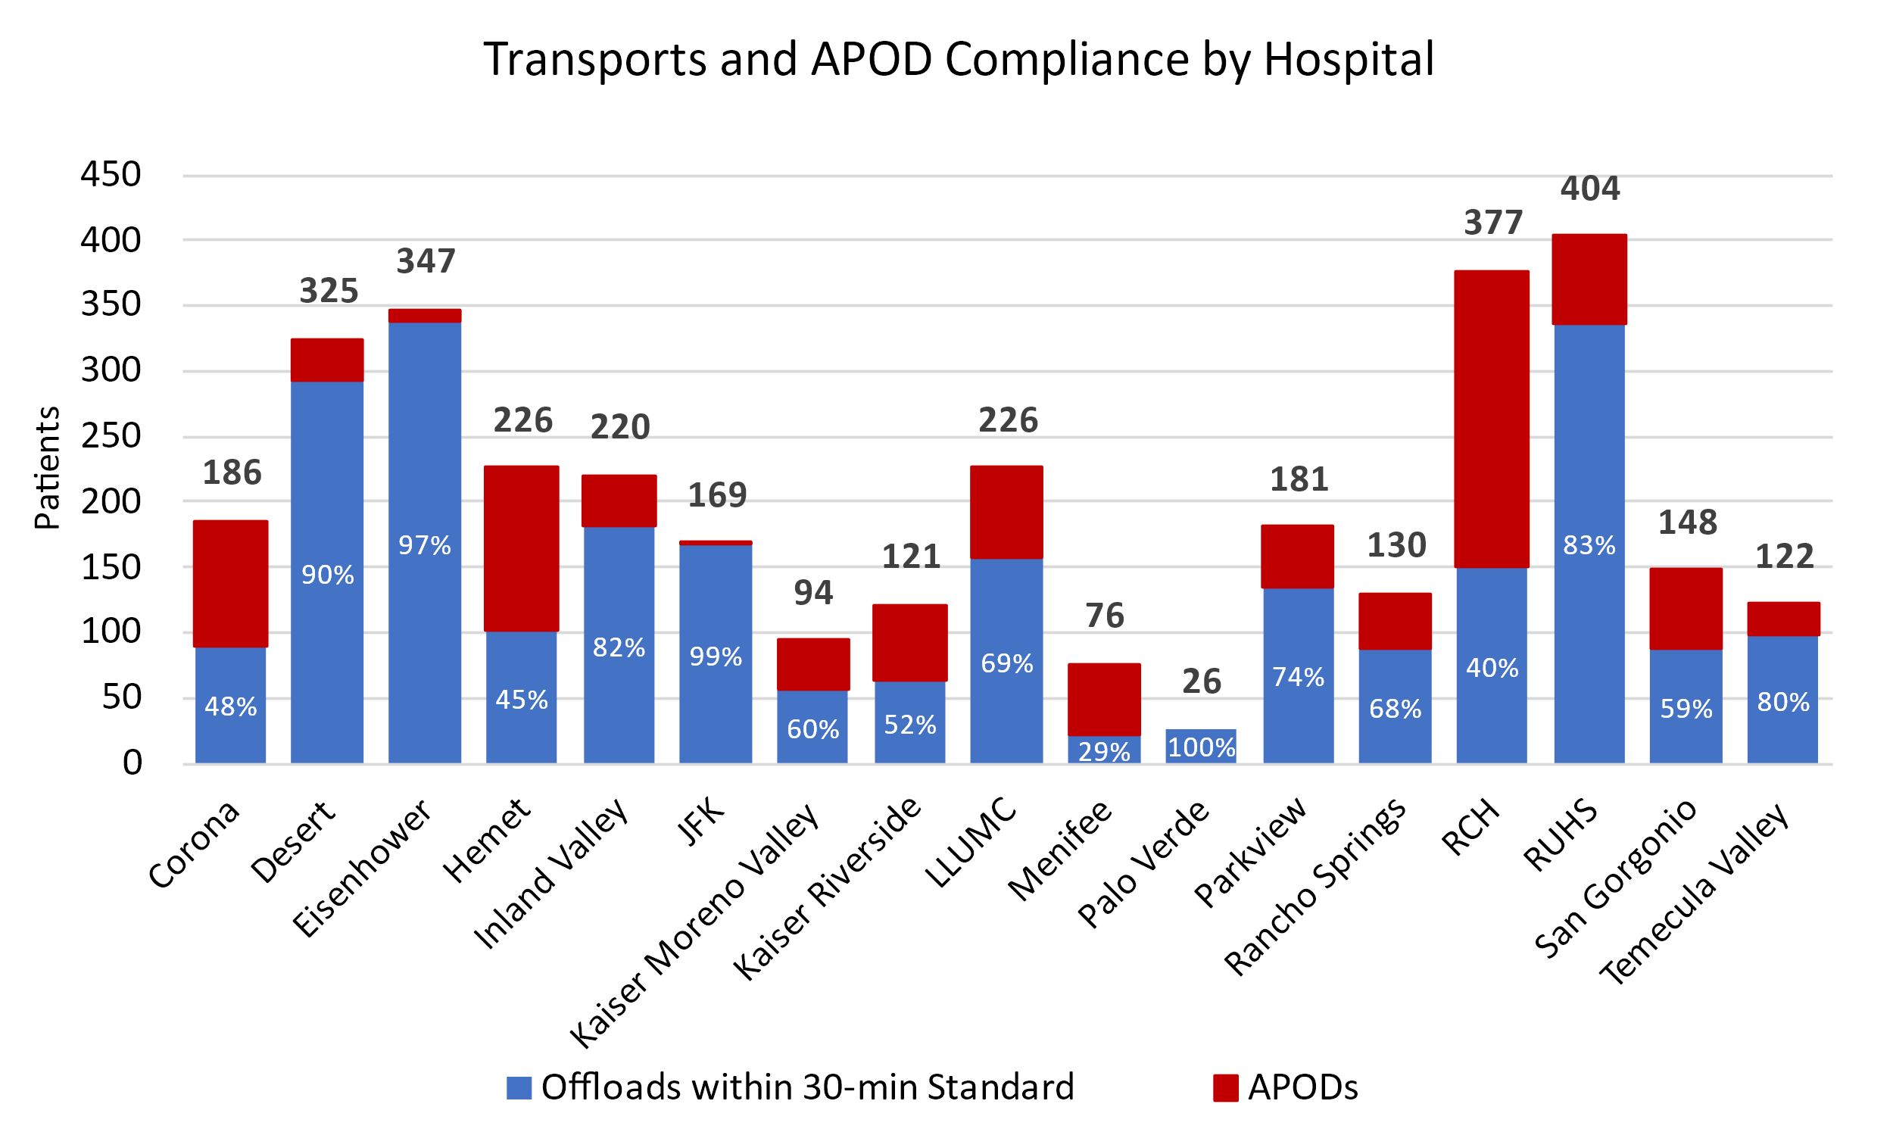

Ambulance redirection

REMSA Policy 6104 allows redirection of ambulances away from hospitals experiencing significant Ambulance Patient Offload Delays (APOD) to the next most appropriate facility. Significant APOD is defined as a patient remaining on an ambulance gurney for 90 minutes or greater after arrival at the hospital (APOT > 90 min). Standard transfer of care is 30 minutes or less (APOT<30 min). Until the transfer of care is complete (patient is removed from the gurney and hospital staff assume care of the patient), ambulance crews must remain at the hospital and continue care. While patients held on excessive APODs are generally those classified as lower acuity, approximately one-third of the County’s ~600 daily 9-1-1 medical responses are determined by dispatch as critical, requiring immediate medical attention (e.g. cardiac arrest, stroke, traumatic injury). As a result, excessive, or multiple APODs within the same service area impact ambulance timeliness and availability in the field posing direct risk to 9-1-1 patient safety. Ambulance redirection is one strategy to reduce the consequential backlog of EMS services which occurs when there are excessive ambulance delays at hospital emergency departments. Below is the Week 47 countywide breakdown of APOD occurrences where ambulances were documented as held for greater than 90 minutes before transfer of care.
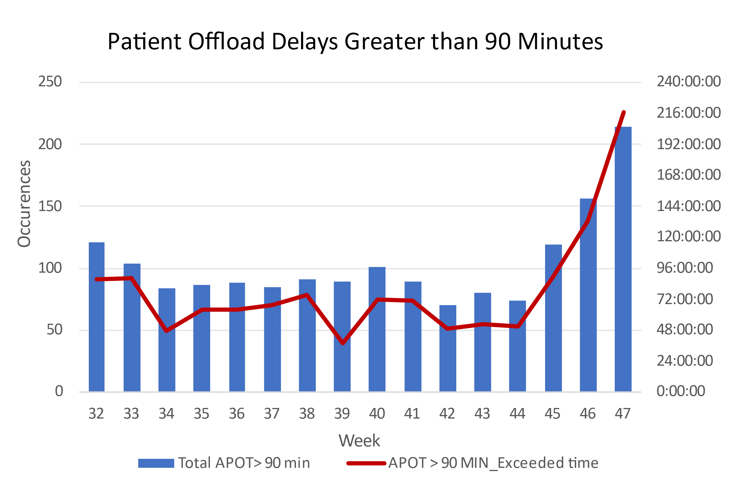

- During Week 47, 214 ambulances were delayed greater than 90 minutes — 37.2% INCREASE from the previous week’s total of 156.
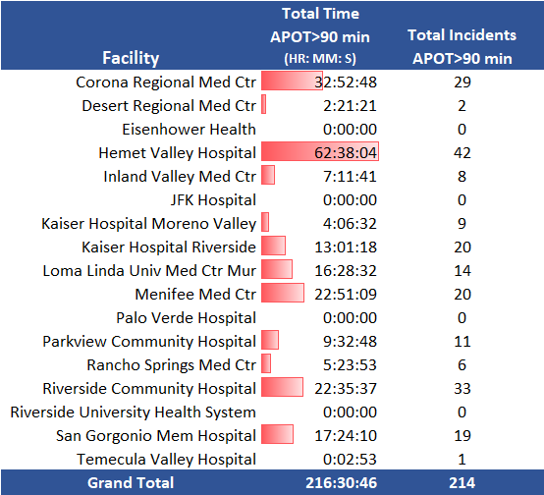

Emergency Treatment Services

Transports to Emergency Treatment Services (ETS) comprise over 3% of overall transports. This is significant enough to impact the EMS system and, therefore, warrants reporting. However, transports to ETS do not meet the EMSA definitions for APOT (see page 10); therefore, they are not included with the previous APOT aggregates.

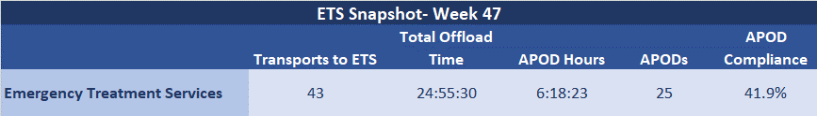

The chart below represents Riverside County’s total number of ETS ambulance transports, patient offload delay (APOD), and percent compliance for the current week and a rolling 15 weeks prior.
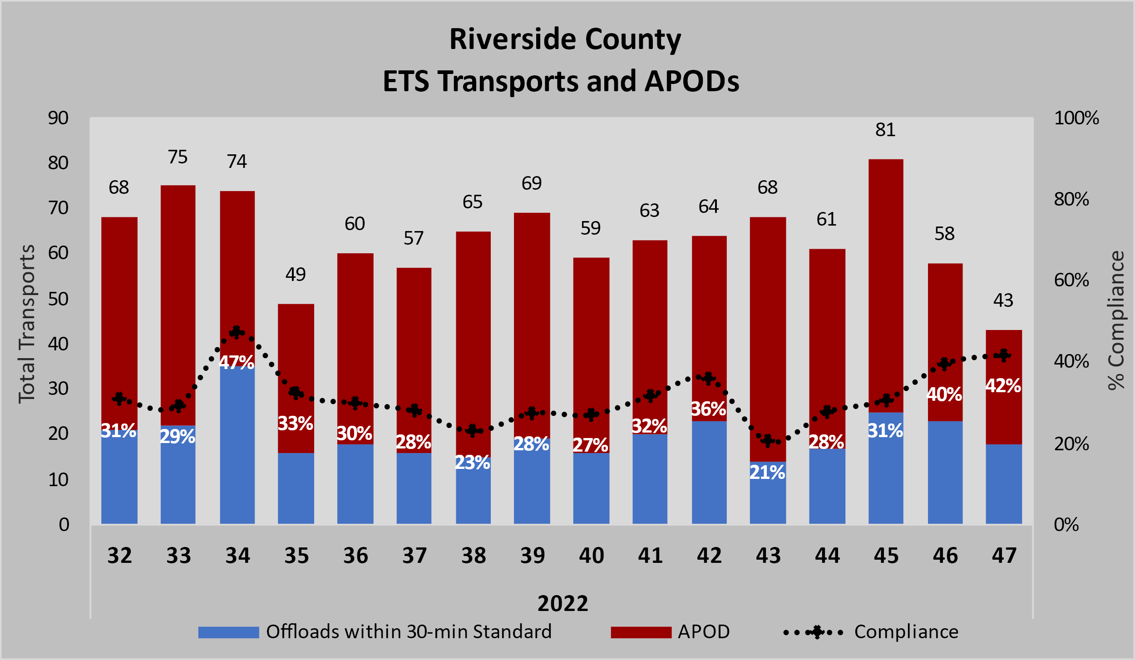

- During Week 47, there were a total of 25 ETS APODs greater than 30 minutes— 28.6% DECREASE from the previous week’s total of 35.

ILI - Influenza-Like Illness Response

While influenza is detected year-round, it is most common during fall and winter. Increases in influenza-like-illness (ILI) generally begin in October and peak sometime between December and February (https://www.cdc.gov/flu/about/season/flu-season.htm).

Hospital Emergency Departments (EDs) generally experience an increase in volume during flu season which, in turn, can impact Ambulance Patient Offload Time. The purpose of the Riverside County EMS system ILI (Influenza-like Illness) reporting is to improve tracking of influenza-related activity and facilitate EMS preparedness in the event of a significant surge event, similar or greater than that observed during the 2017-18 flu season.

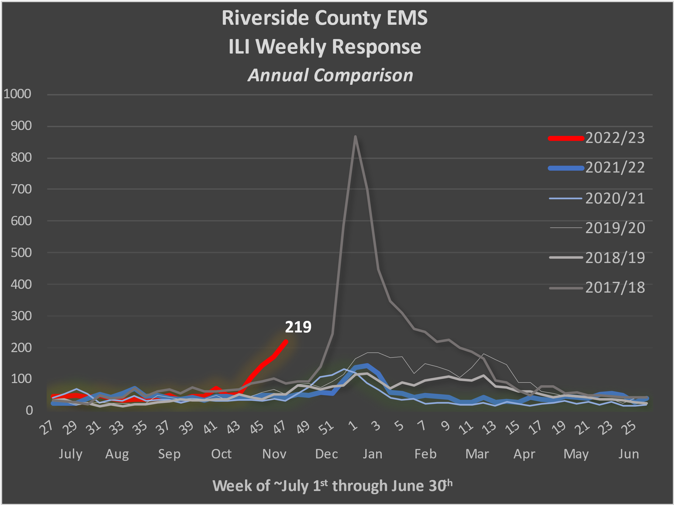
Week 47 (~October 1st) is defined by the Center for Disease Control (CDC) as the expected start of increasing influenza activity, or “flu season”. Riverside County EMS Agency monitors influenza-like illness (ILI) year-round for better detection of seasonal or abnormal surges which can impact EMS utilization.

The ILI trigger evaluates electronic patient report (ePCR) data using the following methodology:

- Filters primary or secondary impression of code J11 (Influenza due to unidentified influenza virus) OR
- A primary / secondary impression code J80, J98.09 (Acute respiratory distress syndrome, Respiratory disorder unspecified) with a match in the narrative for ILI, influenza like illness, Flu, Flu-, Flu\., or influenza OR
- Any incident with a match in the narrative for ILI, influenza like illness, Flu, Flu-, Flu\., or influenza.

ILI - INFLUENZA-LIKE ILLNESS RESPONSE (CONT. )

EMS ILI response two standard deviations above the calculated baseline average during non-peak flu seasons is considered a surge in flu activity. For the current Flu season 2020-’21, the standard deviation threshold value is not calculated as there was abnormal non-peak flu season behavior due to COVID-19. The threshold value listed in the graph is based on previous years non-peak flu season. Surges are identified as color levels adapted from the CDPH Standards and Guidelines for Healthcare Surge During Emergencies (actual response status for the EMS system may differ):

https://www.cdph.ca.gov/Programs/EPO/CDPH%20Document%20Library/FinalEOM712011.pdf
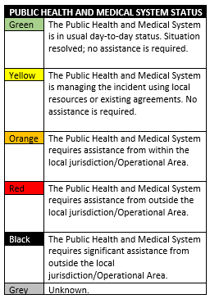
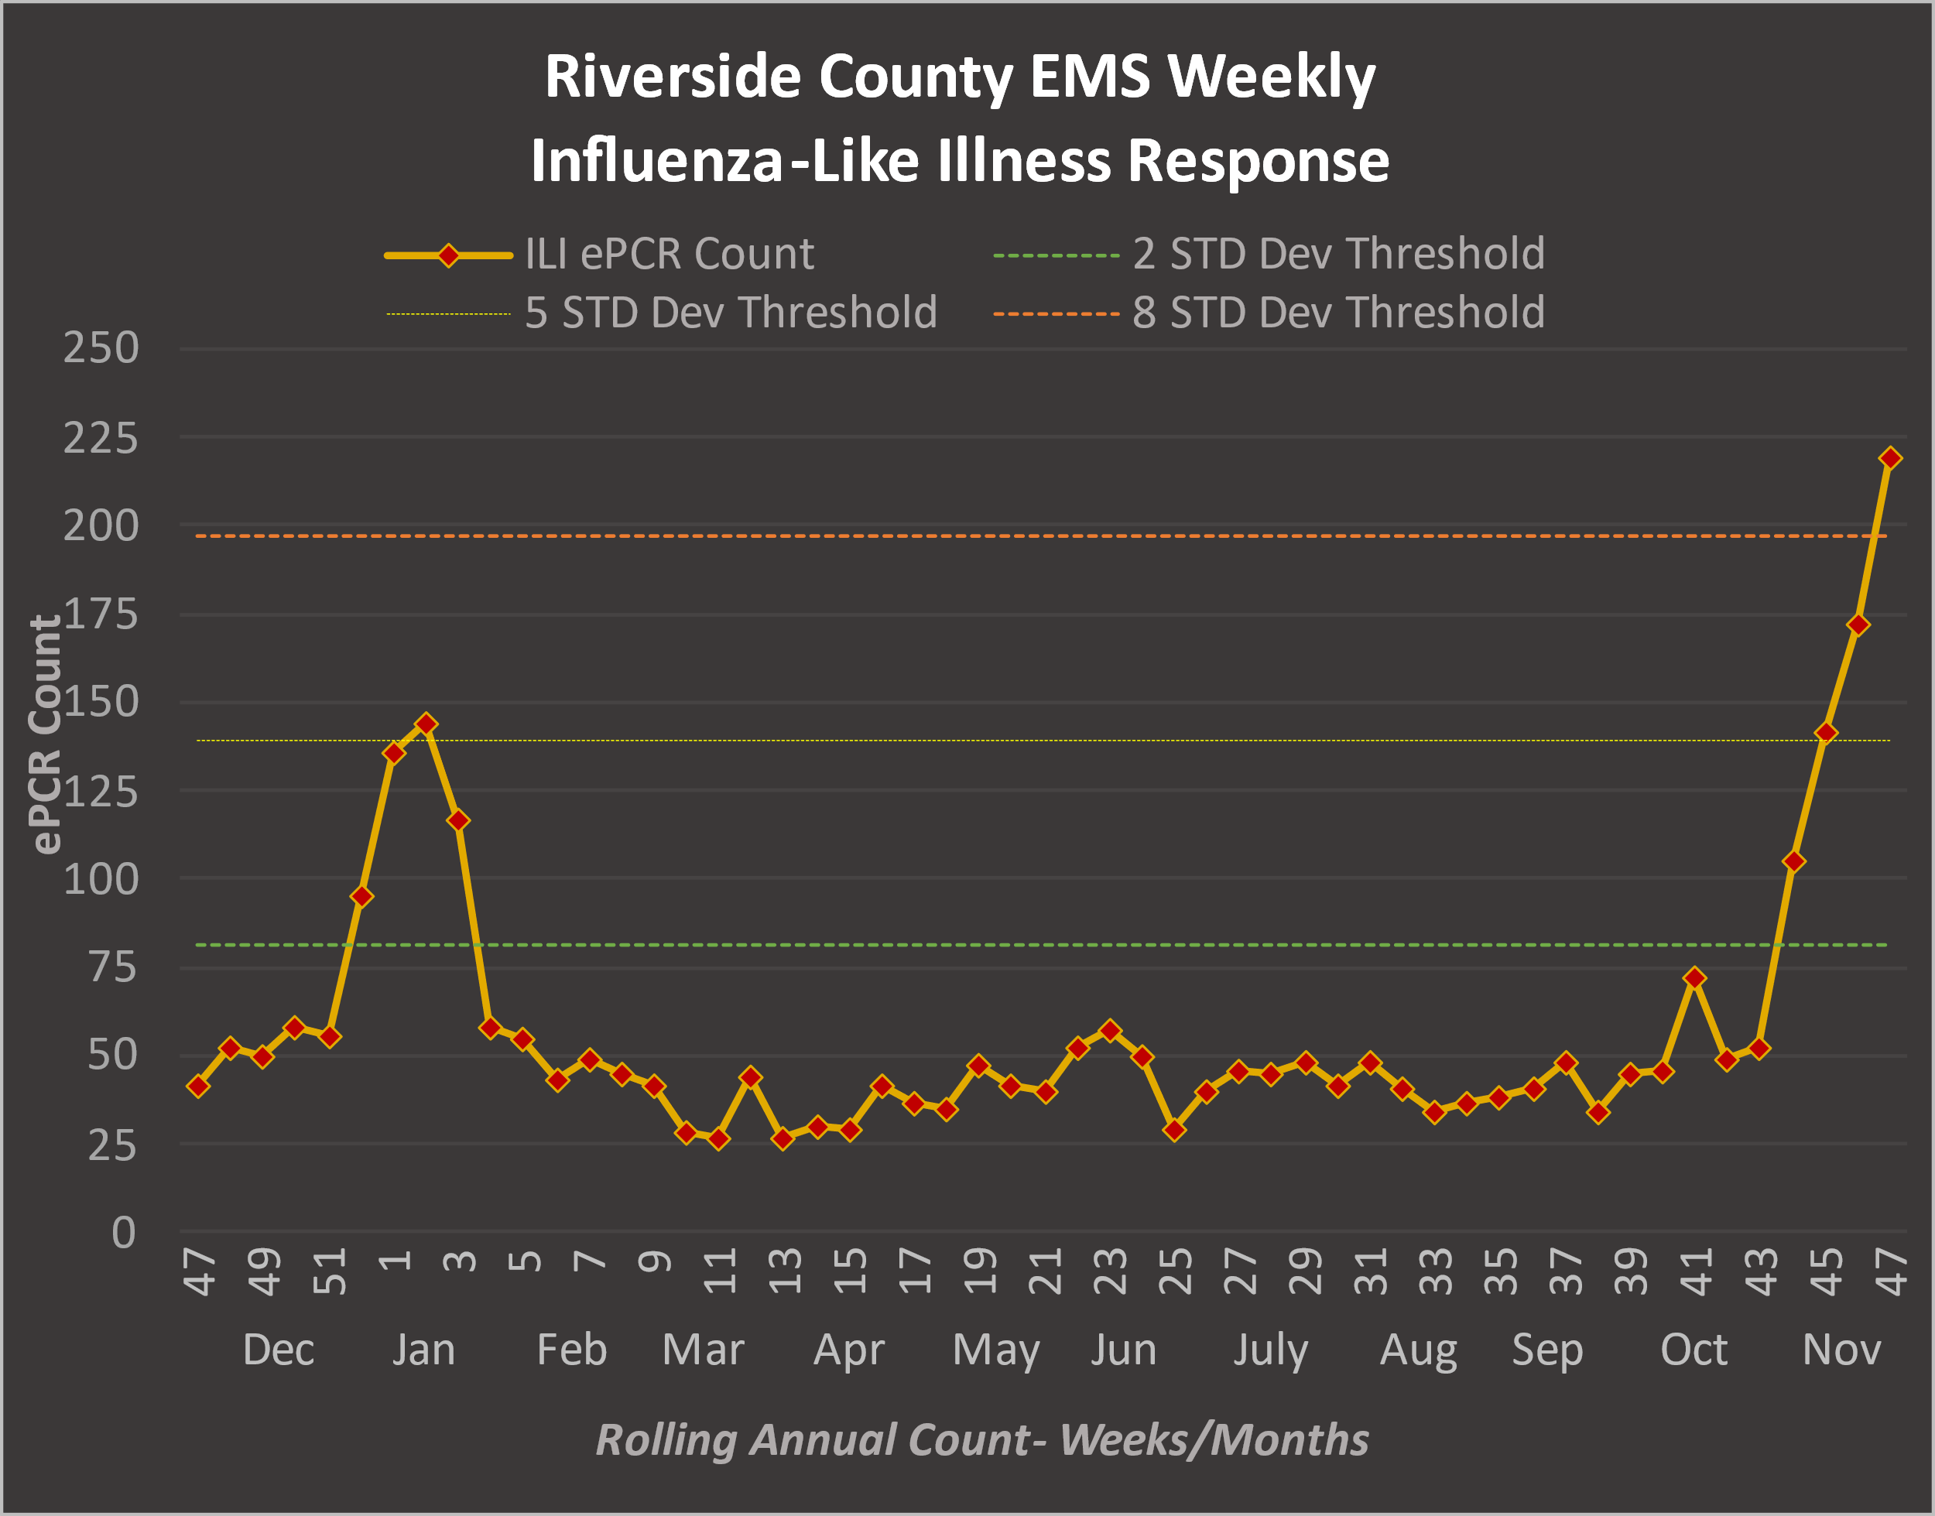

During Week 47, EMS ILI response is ABOVE the EIGHT (8) standard deviation threshold compared to ILI activity during non-peak flu season levels (weeks 13-39).

ILI-related EMS response in Riverside County, ePCR distribution map: Week 47

Riverside County Public Health Influenza-Like Illness Data

Riverside County Public Health Department – DOPH collects Emergency Department ILI activity data from the Center for Disease Control’s (CDC) Early Notification of Community-based Epidemics (ESSENCE) system as part of the National Syndromic Surveillance Program (NSSP). Fifteen of 17 Riverside County hospitals participate in ESSENCE. The graph below provides a comparison between Riverside County’s EMS ILI responses and Emergency Department (ED) ILI visits for the current year compared to the previous year.
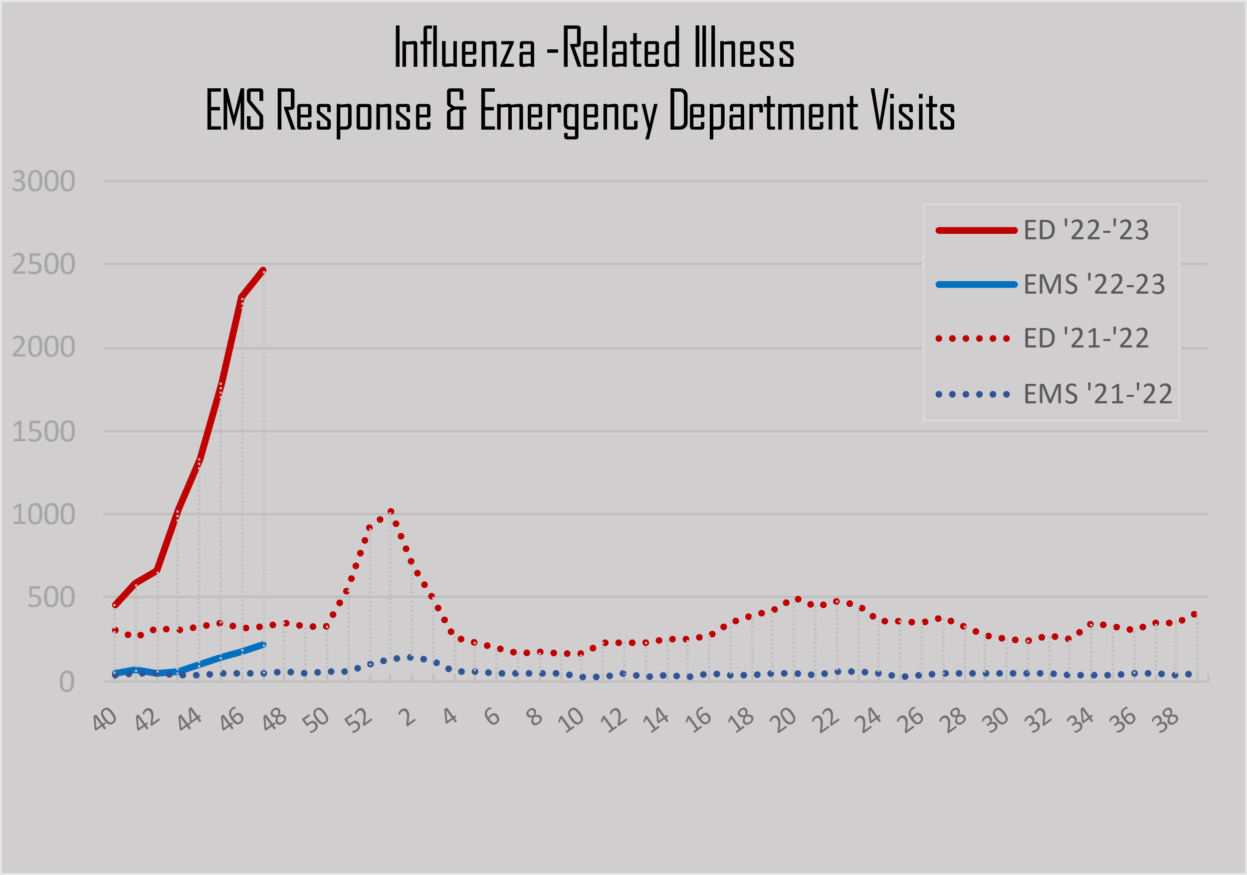

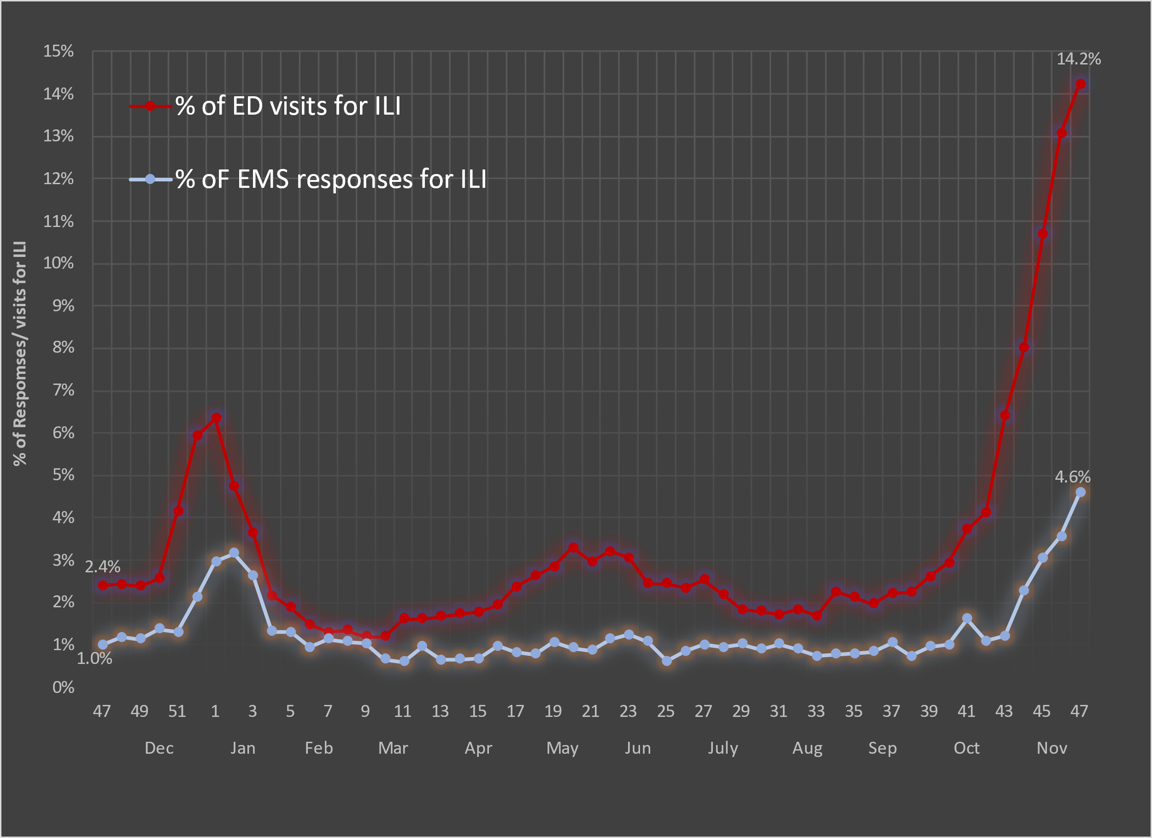
EMS ILI responses and ED ILI visits as a percentage of their respective total volume – adapted from CDC methodology
For Riverside County Public Health Department Influenza Reporting, see https://www.rivco-diseasecontrol.org/

ApoT and apoD Definitions

9-1-1 Ambulance Response
For the purpose of reporting valid, unduplicated response counts, only ground transport units responding to 9-1-1 incidents are included in this report. This excludes records from First Responder Fire Agencies arriving on scene with transport agencies as part of Riverside County’s 9-1-1 dual medical response system. It also excludes non-emergency interfacility or other transport types (i.e., air ambulance) where a 30-minute time standard would not apply.

Ambulance Patient Offload Time (APOT)
The time interval between the arrival of an 9-1-1 patient at an Emergency Department (ED) and the time that patient is transferred from the ambulance gurney to a bed, chair, or other acceptable location, and the ED assumes responsibility of care. The Clock Start (eTimes.11) is the time of patient arrival at the destination (hospital), and the Clock Stop (eTimes.12) is the time patient care is transferred. REMSA obtains both times from the ePCR.

Ambulance Patient Offload Delay (APOD)
Any delay in ambulance patient offload time (APOT) that exceeds the local ambulance patient offload time standard of 25/30 minutes (Riverside County EMS Agency applies a 30-minute standard). This shall also be synonymous with “non-standard patient offload time” as referenced in the Health and Safety Code. If the transfer of care and patient offload from the ambulance gurney exceeds the 30-minute standard, it will be documented and tracked as APOD. The Riverside County ePCR system requires medics to enter an “ APOD Reason” when APOT exceeds the 30-minute standard. While the number of APODs documented as non-ED-related is nominal, beginning in Week-1 of 2022, only delays identified as having an ED origin are counted against APOD compliance for a more precise metric.

APOD Compliance

Frequency comparison expressed in percentage between the total number of transports and those resulting in APODs having a documented ED-related origin.

Emergency Treatment Services (ETS) Ambulance Patient Offload Delay (APOD)
Transport to ETS maintains the 30-minute offload standard, however, ETS APOD includes 9-1-1 and interfacility transports (IFTs) as approximately three-quarters of ETS transports are IFTs from other medical facilitates.
-For inquiries, please contact EMS Administrator, TDouville@rivco.org -Current report prepared by Sudha Mahesh & Catherine Borna Farrokhi, Riverside County EMS Agency -ESSENCE Emergency Department data compiled by Rick Lopez, Riverside County Department of Public Health
Additional Data Definitions
Data in this report has been collected from ePCRs (electronic patient care reports) from FirstWatch® and are available after they have been completed by the provider. There is, therefore, an inherent latency to the availability of these records. Due to this latency, subsequent reports may feature slightly different aggregate numbers than earlier reports for the same reporting period. The difference is insignificant (averaging less than .1%) and does not impact overall compliance.
Data in this report includes all transports to the 17 hospitals monitored by REMSA in the respective week relative to the date and time the incident originates (eTimes.03--Dispatch Notified Date/Time). For example, if an incident originates on day-7 of the current reporting week, and the patient is subsequently transferred to the care of an emergency department after midnight which falls on day-1 of the subsequent week, that incident will be included in the current reporting week.

Health and Safety Code Division 2.5, Chapter 3, Article 1, Section 1797.120(b)
Ambulance Patient Offload Time (APOT) Standardized Methods for Data Collection and Reporting, approved by EMS Commission 12/14/2016. https://emsa.ca.gov/wp-content/uploads/sites/71/2017/09/APOT-Methodology_Guidance-2016.pdf
³ Ibid., APOT-1 Specifications
REMSA Policy 4109, Transfer of Patient Care. https://www.remsa.us/policy/4109.pdf 7 Calkins MM, Isaksen TB, Stubbs BA, Yost MG, Fenske RA (2016). Impacts of extreme heat on emergency medical service calls in King County, Washington, 2007-2012:relative risk and time series analyses of basic and advanced life support. Environ Health. doi: 10.1186/s12940-016-0109-0 ⁸ Sheridan SC, Kalkstein AM, Kalkstein LS (2009). Trends in heat-related mortality in the United States, 1975–2004. Natural Hazards 50:1, 145-160 9 Guo Y, Gasparrini A, Armstrong BG (2017). Heat Wave and Mortality: A Multicountry, Multicommunity Study. Environ Health Perspect. 2017;125(8):087006. doi:10.1289/EHP1026 1⁰ CDC, Climate and Health Program. 2010. https://www.cdc.gov/climateandhealth/effects/default.htm

